**Capstone Project - The Battle of Neighborhoods**

# Section 1: Introduction

In this section I will clearly define the idea of my choosing, where I leverage the Foursquare location data to solve the imagined business opportunity.

## Background

There are 100's, maybe even 1000's, of travel sites on the Internet, including [FourSquare](https://github.com/davidcolton/Coursera_Capstone/blob/master/www.foursquare.com), that will tell you all about places to go, things to see, restaurants to eat at, bars to drink in, nightclubs to part the night away in and then where to go in the morning to get breakfast and a strong coffee. The problems with these sites is that they are one dimensional. If you want to find out all this information about a city you plan to visit next month, **you** have to do the hard work. Also, just because a venue is the hottest place to go for a night out does not always mean that the unwitting tourist should just ramble in unprepared. The areas surrounding this new venue might be riddled with crime including muggings, car theft and assault, for example. Approach the venue from any direction other than from the north and you could be putting your life in danger. This is when my idea comes in.

Imagine the following scenario:

1. You like to plan ahead and always review your options and make your choices about where you will visit and eat up front before you travel.
2. You are flying to Chicogo for a Data Science Conference.
3. You arrive in Chicago the day the conference starts but you've managed to convince your boss to delay your return by a few days giving you time to explore.
4. But you know no one in Chicago to show you around to all the top sites and to bring you to the best restaurants.
5. Also the last time you went to a conference you were mugged and had you passport. money and credit cards stolen so you're now nervous of going somewhere without first researching the venue and the surrounding area.
6. The conference is next week and you don't have time to do all the research you'd like.

**What do you do ... ?**

## Project Idea

My idea for the Capstone Project is to show that when driven by venue and location data from FourSquare, backed up with open source crime data, that it is possible to present the cautious and nervous traveller with a list of attractions to visit supplementd with a graphics showing the occurance of crime in the region of the venue.

A high level approach is as follows:

1. The travellers decides on a city location [in this case Chicago]
2. The ForeSquare website is scrapped for the top venues in the city
3. From this list of top venues the list is augmented with additional grographical data
4. Using this additional geographical data the top nearby restaurents are selects
5. The historical crime within a predetermined distance of all venues are obtained
6. A map is presented to the to the traveller showing the selected venues and crime statistics of the area.
7. The future probability of a crime happening near or around the selected top sites is also presented to the user

#### Who is this solution targeted at

This solution is targeted at the cautious traveller. The want to see all the main sites of a city that they have never visited before but at the same time, for whatever reaons unknown, they want to be able to do all that they can to make sure that they stay clear of trouble i.e. is it safe to visit this venue and this restaurant at 4:00 pm in the afternoon.

Some examples of envisioned users include:

* A single white female traveller
* An elderly traveller that has had previous back experiences when travelling

There are many data science aspect of this project including:

1. Data Acquisition
2. Data Cleansing
3. Data Analysis
4. Machine Learning
5. Prediction

Now that the conference is over the Data Sceintist can explore Chigago and feel much safer.

# Section 2: Data

## Data Description

In this section, I will describe the data used to solve the problem as described previously.

As noted below in the Further Development Section, it is possible to attempt quite complex and sophisticated scenarios when approaching this problem. However, given the size of the project and for simplicity only the following scenario will be addressed:

1. Query the FourSqaure website for the top sites in Chicago
2. Use the FourSquare API to get supplemental geographical data about the top sites
3. Use the FourSquare API to get top restaurent recommendations closest to each of the top site
4. Use open source Chicago Crime data to provide the user with additional crime data

## Top Sites from FourSquare Website

Although FourSquare provides a comprehensive API, one of the things that API does not easily support is a mechanism to directly extract the top N sites / venues in a given city. This data, however, is easily available directly from the FourSquare Website. To do this simply go to [www.foursquare.com](http://www.foursquare.com/), enter the city of your choise and select Top Picks from I'm Looking For selection field.

Using BeautifulSoup and Requests the results of the Top Pick for Chicago was retrieved. A sample venue is shown below:

<div class="venueDetails">

<div class="venueName">

<h2>

<a href="/v/millennium-park/42b75880f964a52090251fe3" target="_blank">Millennium Park

</a>

</h2>

</div>

<div class="venueMeta">

<div class="venueScore positive" style="background-color: #00B551;" title="9.7/10 - People like this place">9.7</div>

<div class="venueAddressData">

<div class="venueAddress">201 E Randolph St (btwn Columbus Dr &amp; Michigan Ave), Chicago</div>

<div class="venueData"><span class="venueDataItem"><span class="categoryName">Park</span><span class="delim"> • </span></span>

</div>

</div>

</div>

</div>

From this HTML the following data can be extracted:

* Venue Name
* Venue Score
* Venue Category
* Venue HREF
* Venue ID [Extracted from the HREF]

A sample of the extracted data is given below:

| **id** | **score** | **category** | **name** | **href** |
| --- | --- | --- | --- | --- |
| 42b75880f964a52090251fe3 | 9.7 | Park | Millennium Park | /v/millennium-park/42b75880f964a52090251fe3 |
| 4b9511c7f964a520f38d34e3 | 9.6 | Trail | Chicago Lakefront Trail | /v/chicago-lakefront-trail/4b9511c7f964a520f38... |
| 49e9ef74f964a52011661fe3 | 9.6 | Art Museum | The Art Institute of Chicago | /v/the-art-institute-of-chicago/49e9ef74f964a5... |
| 4f2a0d0ae4b0837d0c4c2bc3 | 9.6 | Deli / Bodega | Publican Quality Meats | /v/publican-quality-meats/4f2a0d0ae4b0837d0c4c... |
| 4aa05f40f964a520643f20e3 | 9.6 | Theater | The Chicago Theatre | /v/the-chicago-theatre/4aa05f40f964a520643f20e3 |

We will have a closer look at this data gather later on when the supplemental geographical data has been added.

## Supplemental Geographical Data

Using the id field extracted from the HTML it is then possible to get further supplemental geographical details about each of the top sites from FourSquare using the following sample API call:

# Get the properly formatted address and the latitude and longitude

url = 'https://api.foursquare.com/v2/venues/{}?client_id={}&client_secret={}&v={}'.format(

venue_id,

cfg['client_id'],

cfg['client_secret'],

cfg['version'])

result = requests.get(url).json()

result['response']['venue']['location']

The *requests* return a JSON object which can then be queried for the details required. The last line in the sample code above returns the following sample JSON:

From this the following attributes are extracted:

* Venue Address
* Venue Postalcode
* Venue City
* Venue Latitude
* Venue Longitude

## Final FourSquare Top Sites Data

A sample of the final FourSquare Top Sites data is shown below:

| **id** | **score** | **category** | **name** | **address** | **postalcode** | **city** | **href** | **latitude** | **longitude** |
| --- | --- | --- | --- | --- | --- | --- | --- | --- | --- |
| 42b75880f964a52090251fe3 | 9.7 | Park | Millennium Park | 201 E Randolph St | 60601 | Chicago | /v/millennium-park/42b75880f964a52090251fe3 | 41.882662 | -87.623239 |
| 4b9511c7f964a520f38d34e3 | 9.6 | Trail | Chicago Lakefront Trail | Lake Michigan Lakefront | 60611 | Chicago | /v/chicago-lakefront-trail/4b9511c7f964a520f38... | 41.967053 | -87.646909 |
| 49e9ef74f964a52011661fe3 | 9.6 | Art Museum | The Art Institute of Chicago | 111 S Michigan Ave | 60603 | Chicago | /v/the-art-institute-of-chicago/49e9ef74f964a5... | 41.879665 | -87.623630 |
| 4f2a0d0ae4b0837d0c4c2bc3 | 9.6 | Deli / Bodega | Publican Quality Meats | 825 W Fulton Market | 60607 | Chicago | /v/publican-quality-meats/4f2a0d0ae4b0837d0c4c... | 41.886642 | -87.648718 |
| 4aa05f40f964a520643f20e3 | 9.6 | Theater | The Chicago Theatre | 175 N State St | 60601 | Chicago | /v/the-chicago-theatre/4aa05f40f964a520643f20e3 | 41.885578 | -87.627286 |

#### Data Analysis and Visualisation

An initial look at the data shows that there are 30 rows of data [as expected] each with 10 attributes. The variable types are all correct except the Venue Rating or Score which will be converted to a float. After converting the score column to a float it can clearly be seen that we have the top venues with a mean of 9.532.

df_top_venues.shape

(30, 10)

df_top_venues.dtypes

id object

score object

category object

name object

address object

postalcode object

city object

href object

latitude float64

longitude float64

dtype: object

df_top_venues.score.describe()

count 30.000000

mean 9.523333

std 0.072793

min 9.400000

25% 9.500000

50% 9.500000

75% 9.600000

max 9.700000

Name: score, dtype: float64

We are now ready to get the top restaurents within 500 meters of each of the top sites.

## FourSquare Restaurent Recommendation Data

Using the the list of all id values in the Top Sites DataFrame and the FourSquare categoryID that represents all food venues we now search for restaurants within a 500 meter radius.

# Configure additional Search parameters

categoryId = '4d4b7105d754a06374d81259'

radius = 500

limit = 15

url = 'https://api.foursquare.com/v2/venues/search?client_id={}&client_secret={}&ll={},{}&v={}&categoryId={}&radius={}&limit={}'.format(

cfg['client_id'],

cfg['client_secret'],

ven_lat,

ven_long,

cfg['version'],

categoryId,

radius,

limit)

results = requests.get(url).json()

The requests returns a JSON object which can then be queried for the restaurant details required. A sample restaurnt from the results returned is shown below:

{

"referralId":"v-1538424503",

"hasPerk":"False",

"venuePage":{

"id":"135548807"

},

"id":"55669b9b498ee34e5249ea61",

"location":{

"labeledLatLngs":[

{

"label":"display",

"lng":-87.62460021795313,

"lat":41.88169538551873

}

],

"crossStreet":"btwn E Madison & E Monroe St",

"postalCode":"60603",

"formattedAddress":[

"12 S Michigan Ave (btwn E Madison & E Monroe St)",

"Chicago, IL 60603",

"United States"

],

"distance":155,

"city":"Chicago",

"lng":-87.62460021795313,

"neighborhood":"The Loop",

"cc":"US",

"state":"IL",

"address":"12 S Michigan Ave",

"lat":41.88169538551873,

"country":"United States"

},

"name":"Cindy's",

"categories":[

{

"pluralName":"Gastropubs",

"id":"4bf58dd8d48988d155941735",

"name":"Gastropub",

"primary":"True",

"icon":{

"prefix":"https://ss3.4sqi.net/img/categories_v2/food/gastropub_",

"suffix":".png"

},

"shortName":"Gastropub"

}

]

},

From this JSON the following attributes are extraced and added to the Dataframe:

* Restaurant ID
* Restaurant Category Name
* Restaurant Category ID
* Restaurant Nest_name
* Restaurant Address
* Restaurant Postalcode
* Restaurant City
* Restaurant Latitude
* Restaurant Longitude
* Venue Name
* Venue Latitude
* Venue Longitude

The only piece of data that is missing is the Score or Rating of the Restaurant. To get this we need to make another FourSquare API query using the id of the Restaurant:

# Get the restaurant score and href

rest_url = 'https://api.foursquare.com/v2/venues/{}?client_id={}&client_secret={}&v={}'.format(

rest_id,

cfg['client_id'],

cfg['client_secret'],

cfg['version'])

result = requests.get(rest_url).json()

rest_score = result['response']['venue']['rating']

Using just the data in this DataFrame we will be able to generate maps displaying the chosen Top List Venue and the best scored surrounding restaurants. A sample of this data is shown below:

| **id** | **score** | **category** | **categoryID** | **name** | **address** | **postalcode** | **city** | **latitude** | **longitude** | **venue_name** | **venue_latitude** | **venue_longitude** |
| --- | --- | --- | --- | --- | --- | --- | --- | --- | --- | --- | --- | --- |
| 55669b9b498ee34e5249ea61 | 9.2 | Gastropubs | 4bf58dd8d48988d155941735 | Cindy's | 12 S Michigan Ave | 60603 | Chicago | 41.881695 | -87.624600 | Millennium Park | 41.882662 | -87.623239 |
| 556509d6498e726bdec19fe9 | 8.4 | Burger Joints | 4bf58dd8d48988d16c941735 | Shake Shack | 12 S Michigan Ave | 60603 | Chicago | 41.881673 | -87.624455 | Millennium Park | 41.882662 | -87.623239 |
| 49e749fbf964a52086641fe3 | 9.1 | Gastropubs | 4bf58dd8d48988d155941735 | The Gage | 24 S Michigan Ave | 60603 | Chicago | 41.881319 | -87.624642 | Millennium Park | 41.882662 | -87.623239 |
| 4e879cdc93adfd051d6d609e | 9.2 | Breakfast Spots | 4bf58dd8d48988d143941735 | Wildberry Pancakes & Cafe | 130 E Randolph St | 60601 | Chicago | 41.884599 | -87.623203 | Millennium Park | 41.882662 | -87.623239 |
| 49d8159cf964a520a05d1fe3 | 8.5 | Pubs | 4bf58dd8d48988d11b941735 | Miller's Pub | 134 S Wabash Ave | 60603 | Chicago | 41.879911 | -87.625972 | Millennium Park | 41.882662 | -87.623239 |

Looking at the data we get an interesting insight into the range of restuarants that are included. From a list of 30 top venues only 28 actually had more than 10 to provide the user with a real choice. In total there were 387 restaurants found of which 240 were unique occuring only once in the data. There were 72 categories of restaurants. The mean score of all the restaurants wa 8.23 with a manimum value of 9.5 and a minimum value of 5.3.

Coffee Shops (52) and Pizza Places (29) were the top two most frequently occurring categories but Pie Shops (9.4000) and French Restaurants (9.4000) were the restaurant categories with the highest average score.

# What is the shape of the Restaurants DataFrame

df_restaurant.shape

(387, 13)

# Get a count of the top venues that had more than 10 restaurant within 500 meters

# The number of unique restaurants

# The number of unique restaurant categories

df_restaurant.venue_name.nunique()

28

df_restaurant.name.nunique()

240

df_restaurant.category.nunique()

72

# Look at the data types

df_restaurant.dtypes

id object

score float64

category object

categoryID object

name object

address object

postalcode object

city object

latitude float64

longitude float64

venue_name object

venue_latitude float64

venue_longitude float64

dtype: object

# Describe the Score attribute

df_restaurant.score.describe()

count 387.000000

mean 8.286563

std 0.930138

min 5.300000

25% 7.800000

50% 8.500000

75% 9.000000

max 9.500000

Name: score, dtype: float64

df_restaurant.groupby('category')['name'].count().sort_values(ascending=False)[:10]

category

Coffee Shops 52

Pizza Places 29

Cafés 24

Bakeries 15

Burger Joints 15

Gastropubs 15

New American Restaurants 15

Mexican Restaurants 14

Breakfast Spots 13

Fast Food Restaurants 13

df_restaurant.groupby('category')['score'].mean().sort_values(ascending=False)[:10]

category

Pie Shops 9.4000

French Restaurants 9.4000

Molecular Gastronomy Restaurants 9.3000

Filipino Restaurants 9.2000

Cuban Restaurants 9.1000

Ice Cream Shops 9.0625

Mediterranean Restaurants 9.0600

Korean Restaurants 9.0000

Latin American Restaurants 9.0000

Fish & Chips Shops 9.0000

## Chicago Crime Data

This dataset can be download from the [Chicago Data Portal](https://data.cityofchicago.org/) and reflects reported incidents of crime (with the exception of murders where data exists for each victim) that occurred in the City of Chicago in the last year, minus the most recent seven days. A full desription of the data is available on the site.

Data is extracted from the Chicago Police Department's CLEAR (Citizen Law Enforcement Analysis and Reporting) system. In order to protect the privacy of crime victims, addresses are shown at the block level only and specific locations are not identified.

| **Column Name** | **Type** | **Description** |
| --- | --- | --- |
| CASE# | Plain Text | The Chicago Police Department RD Number (Records Division Number), which is unique to the incident. |
| DATE OF OCCURRENCE | Date & Time | Date when the incident occurred. this is sometimes a best estimate. |
| BLOCK | Plain Text | The partially redacted address where the incident occurred, placing it on the same block as the actual address. |
| IUCR | Plain Text | The Illinois Unifrom Crime Reporting code. This is directly linked to the Primary Type and Description. See the list of IUCR codes at <https://data.cityofchicago.org/d/c7ck-438e>. |
| PRIMARY DESCRIPTION | Plain Text | The primary description of the IUCR code. |
| SECONDARY DESCRIPTION | Plain Text | The secondary description of the IUCR code, a subcategory of the primary description. |
| LOCATION DESCRIPTION | Plain Text | Description of the location where the incident occurred. |
| ARREST | Plain Text | Indicates whether an arrest was made. |
| DOMESTIC | Plain Text | Indicates whether the incident was domestic-related as defined by the Illinois Domestic Violence Act. |
| BEAT | Plain Text | Indicates the beat where the incident occurred. A beat is the smallest police geographic area – each beat has a dedicated police beat car. Three to five beats make up a police sector, and three sectors make up a police district. The Chicago Police Department has 22 police districts. See the beats at <https://data.cityofchicago.org/d/aerh-rz74>. |
| WARD | Number | The ward (City Council district) where the incident occurred. See the wards at <https://data.cityofchicago.org/d/sp34-6z76>. |
| FBI CD | Plain Text | Indicates the crime classification as outlined in the FBI's National Incident-Based Reporting System (NIBRS). See the Chicago Police Department listing of these classifications at <http://gis.chicagopolice.org/clearmap_crime_sums/crime_types.html>. |
| X COORDINATE | Plain Text | The x coordinate of the location where the incident occurred in State Plane Illinois East NAD 1983 projection. This location is shifted from the actual location for partial redaction but falls on the same block. |
| Y COORDINATE | Plain Text | The y coordinate of the location where the incident occurred in State Plane Illinois East NAD 1983 projection. This location is shifted from the actual location for partial redaction but falls on the same block. |
| LATITUDE | Number | The latitude of the location where the incident occurred. This location is shifted from the actual location for partial redaction but falls on the same block. |
| LONGITUDE | Number | The longitude of the location where the incident occurred. This location is shifted from the actual location for partial redaction but falls on the same block. |
| LOCATION | Location | The location where the incident occurred in a format that allows for creation of maps and other geographic operations on this data portal. This location is shifted from the actual location for partial redaction but falls on the same block. |

Not all of the attributes are required so on the following data was imported:

* Date of Occurance
* Block
* Primary Description
* Ward
* Latitude
* Longitude

A sample of the imported data is shown.

| **CASE#** | **DATE OF OCCURRENCE** | **BLOCK** | **PRIMARY DESCRIPTION** | **WARD** | **LATITUDE** | **LONGITUDE** |
| --- | --- | --- | --- | --- | --- | --- |
| JB241987 | 04/28/2018 10:05:00 PM | 009XX N LONG AVE | NARCOTICS | 37.0 | 41.897895 | -87.760744 |
| JB241350 | 04/28/2018 08:00:00 AM | 008XX E 53RD ST | CRIMINAL DAMAGE | 5.0 | 41.798635 | -87.604823 |
| JB245397 | 04/28/2018 09:00:00 AM | 062XX S MICHIGAN AVE | THEFT | 20.0 | 41.780946 | -87.621995 |
| JB241444 | 04/28/2018 12:15:00 PM | 046XX N ELSTON AVE | THEFT | 39.0 | 41.965404 | -87.736202 |
| JB241667 | 04/28/2018 04:28:00 PM | 022XX S KENNETH AVE | ARSON | 22.0 | 41.850673 | -87.735597 |

This data was then processed as follows:

1. Move September 2017 dates to September 2018 The extract of data used was taken mid September which meant that there was half a months data for September 2017 and half a months data for september 2018. These were combined to create a single month.
2. Clean up the column names:
   1. Strip leading & trailing whitespace
   2. Replace multiple spaces with a single space
   3. Remove # characters
   4. Replace spaces with _
   5. Convert to lowercase
3. Change the date of occurance field to a date / time object
4. Add new columns for:
   1. Hour
   2. Day
   3. Month
   4. Year
   5. etc.
5. Split Block into zip_code and street
6. Verify that all rows have valid data

#### Data Analysis and Visualisation

Now let's look at some of the attributes and statistics of the crime dataset.

We will start by looking at the top three crimes and a total count for each crime type:

# What Crimes are the 3 most commonly occuring ones

df[['primary_description', 'case']].groupby(

['primary_description'], as_index=False).count().sort_values(

'case', ascending=False).head(3)

| **primary_description** | **case** |
| --- | --- |
| THEFT | 63629 |
| BATTERY | 49498 |
| CRIMINAL DAMAGE | 27980 |

To get a better understanding of the data we will now visualise it. The number of crimes per month, day and hour were calculated:

[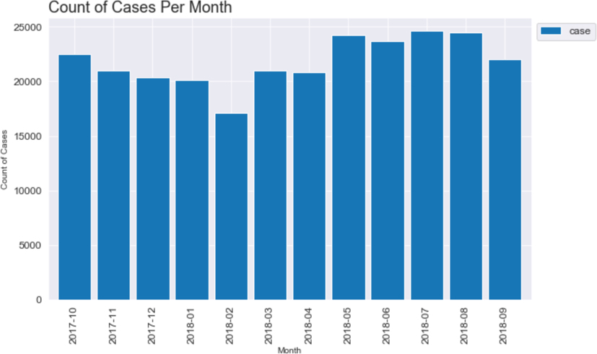](https://github.com/davidcolton/Coursera_Capstone/blob/master/capstone_images/cases_month.jpg)

[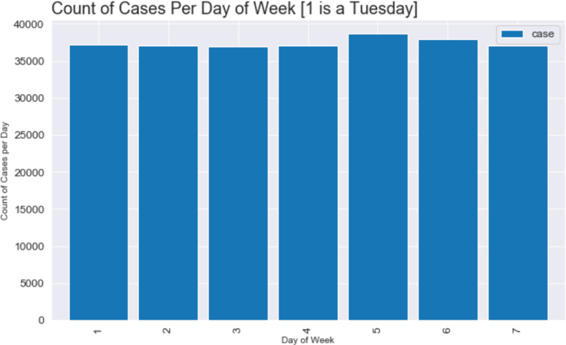](https://github.com/davidcolton/Coursera_Capstone/blob/master/capstone_images/cases_day.jpg)

[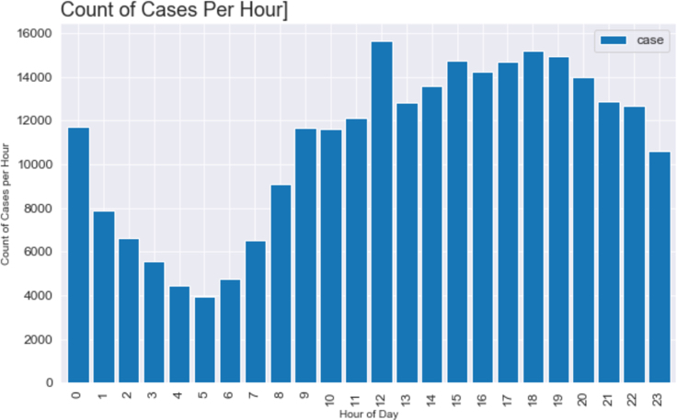](https://github.com/davidcolton/Coursera_Capstone/blob/master/capstone_images/cases_hour.jpg)

Looking at the top three crimes it is clearly visible that the occurrences of theft rise greatly during daylight hours and particularly between the hours of 3:00 pm and 5:00 pm.

[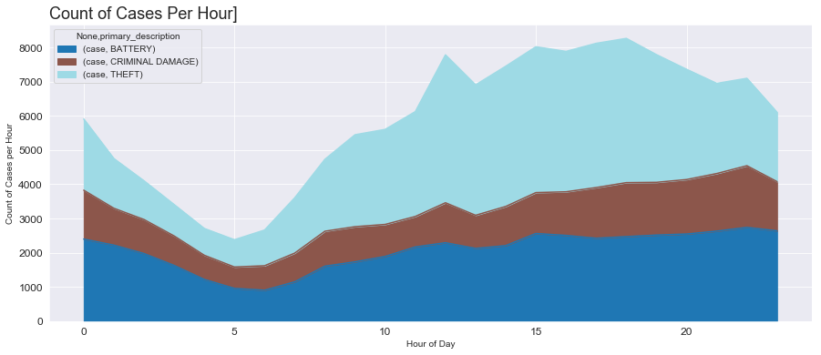](https://github.com/davidcolton/Coursera_Capstone/blob/master/capstone_images/cases_hour_area.png)

Unsuprisingly there little obvious variation in the number of crimes committed per month other than an apparent drop-off in February. There is a small increase in crime reported at the weekend, Saturday and Sunday, but nothing that couldbe considered significant. There is an expected fall-off in reported crime rates after midnight and before eight in the morning.

Finally the crimes data for a single month, August, was super-imposed over a map of Chicago to visualise the distribution of that data:

[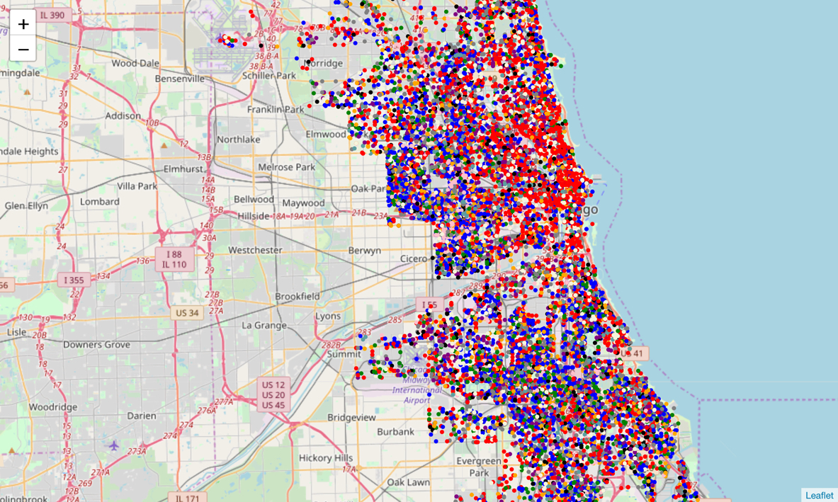](https://github.com/davidcolton/Coursera_Capstone/blob/master/capstone_images/markers.jpg)

The higher frequency of the top two crimes can be easily seen. Red for Theft and Blue for Battery.

Next the crimes were clustered:

[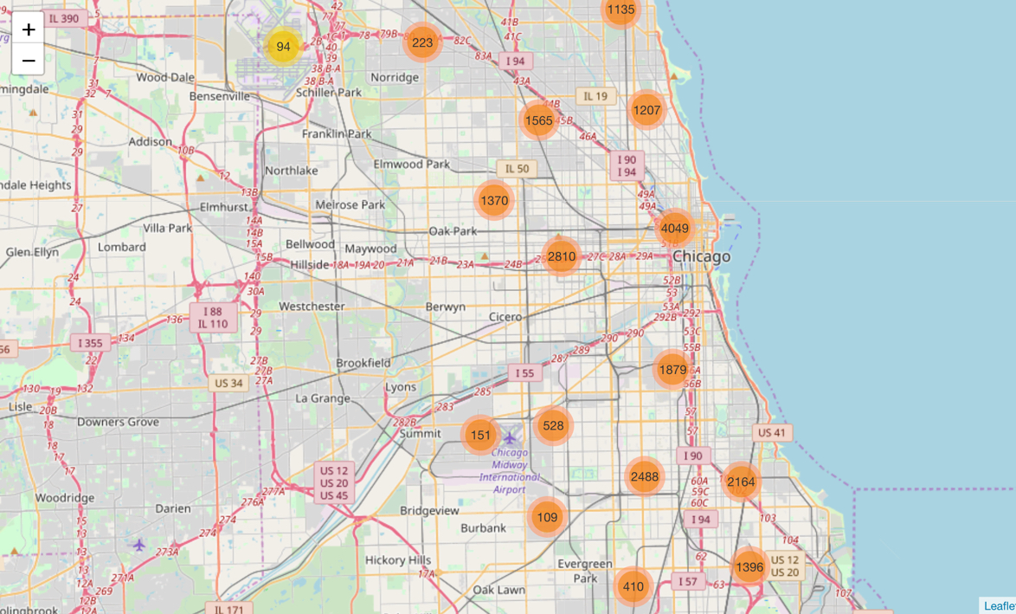](https://github.com/davidcolton/Coursera_Capstone/blob/master/capstone_images/clusters.jpg)

Several obvious clusters of crime locations were visible, particularly in the center of Chicago.

Finally a heat map of the August crimes was created:

[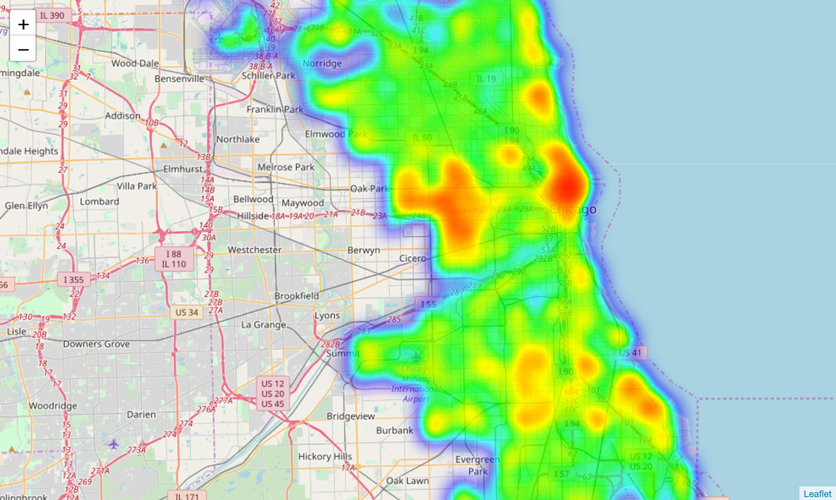](https://github.com/davidcolton/Coursera_Capstone/blob/master/capstone_images/heatmap.jpg)

This reinforces the cluster chart where it can clearly be seen that the center of Chicago and the area around Oak Park have a high crime rate occurrence. It will be interesting to see later if there is a high probability of crime in these areas if one of the top listed venues is located in these areas.